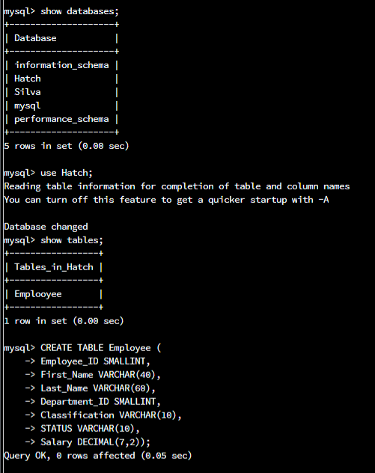  
  
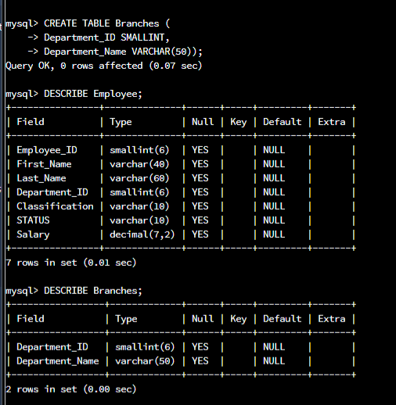  
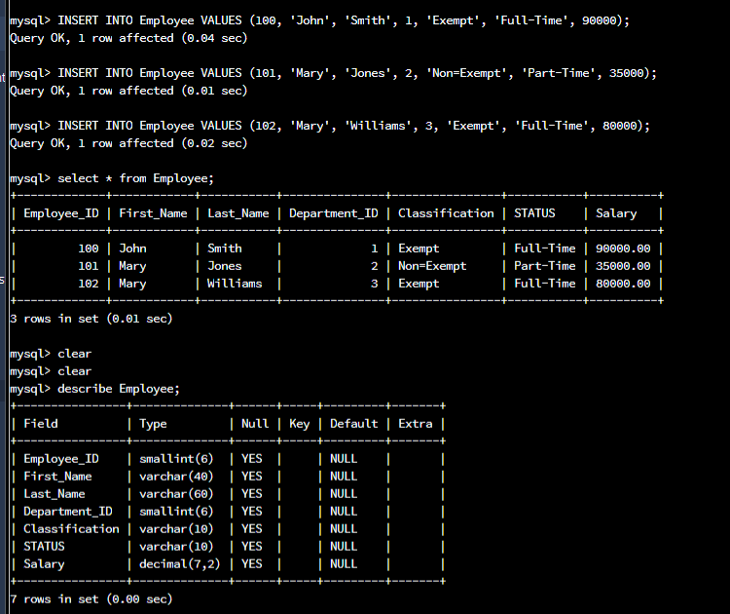  
  
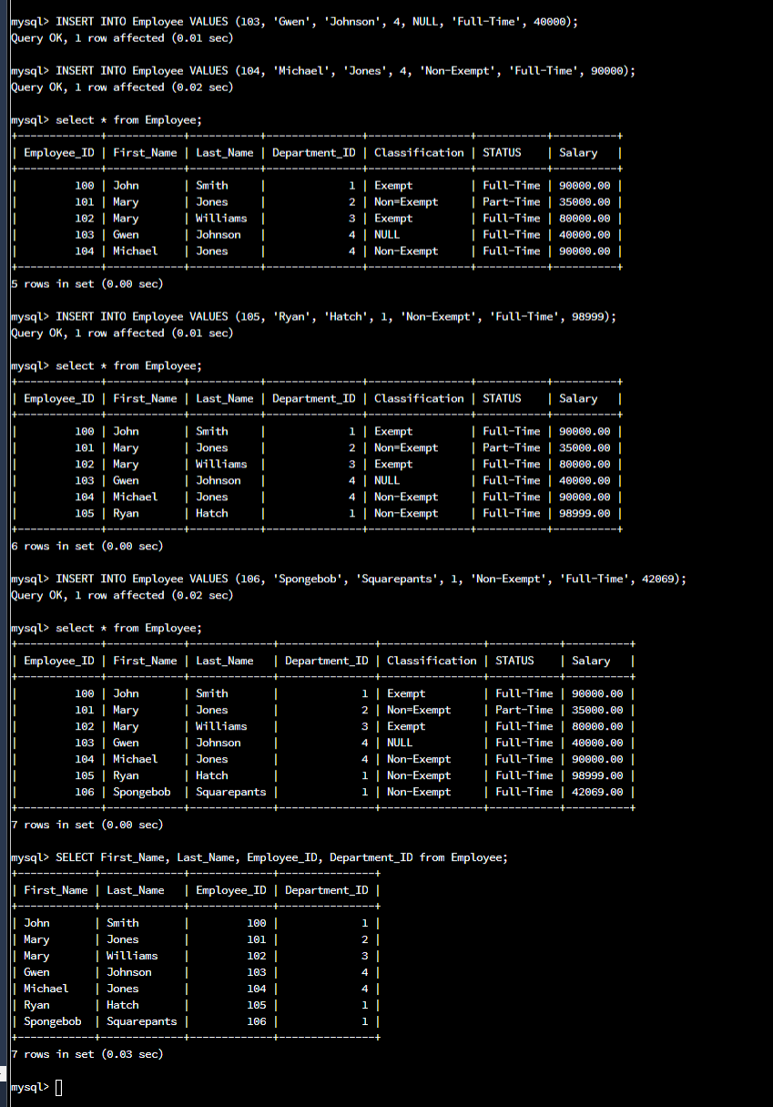

I created Branches table next, and only had two columns.

I entered the database and created the Employee table with 7 different columns. This will allow the database to register and edit the Employee ID, first and last name, the department that they are in, their classification status, whether they are full time or part time, and finally, we input their salary.  
  
This is the foundation of the database.

I put John Smith, Mary Jones, and Mary Williams and their specified columns defining their ID, department, classification, status, and salary amount.

I then entered Gwen and Michael before adding myself and SpongeBob into the database and assigned everyone their specific values before showing the database by using the select command.